Spectroscopic Investigation of Novel Materials
A. Onestone¹ and W. Heisenmont^{2*}
¹Institute of Modern Science, Pacific University, Fiji Islands,
²Department of Engineering, Central University, Icebergen, Greenland
*w.heisenmont@u-iceberg.com

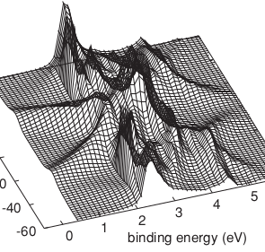
The abstract must contain a title, author list, author affiliations and the abstract text. It may or may not contain figures. The total abstract must not exceed one page. The presenting author’s name is underlined. A contact e-mail address is optional. Font sizes are as follows. Title: 16 pt bold, author list: 12 pt, affiliations: 12 pt italic, main text, references and e-mail address: 11 pt. The preferred font is Times New Roman. References [1] should be numbered and indicated in square brackets.
Figure 1. Theoretical ARPES of Cu(111) for He I light and emission angle of 60 deg [2].

References
[1] A. Onestone and W. Heisenmont, Phys. Chem. Mat. Sci. 26, 1034 (2018).
[2] P. Krüger et al, Phys. Rev. B 83, 115437 (2011)

