This is the title of the presentation
Antony Author¹, Priscilla Presenter² and Beatrice Baker^{1,2,*}
¹Advanced School of Science, Newtown University, 29085 Fiji Islands
²Pharmaceutical Institute, Princess University, New Jersey 08533, USA
* b.baker@bakerstreet.com

Here goes the abstract text. The whole abstract must not exceed one page. The presenter’s name is underlined. The corresponding author is indicated by a star (*) and his/her e-mail address is given after the affiliations. The formats should be as follows. Title 18 pt, author names 12 pt, author affiliations, abstract text and figure captions 11 pt. Title, author names, affiliations are centered. Font: Times New Roman or similar. ……………………………………………………………………………………………………….……………………………………………………………………………………………………………….……………………………………………………………………………………………………………….………………………………………………………………………………………………………….……………
With the advent of big-data science, the foundations of statistical mechanics have recently been called into question. Here we report the first experimental evidence for deviations from the Boltzmann distribution function in a canonical ensemble under heavy neutrino irradiation. …………………………. …………………………………..…………………………………………………………………………………………………………….….………………………………………………………………………………………………………………..………………………………………………………………………………………………………………..…………………………………………………………………………..……………. The data (Fig.1) is analyzed using Bayesian statistics using a novel machine learning algorithm. The experimental findings are supported by extensive, first-principles molecular dynamics.
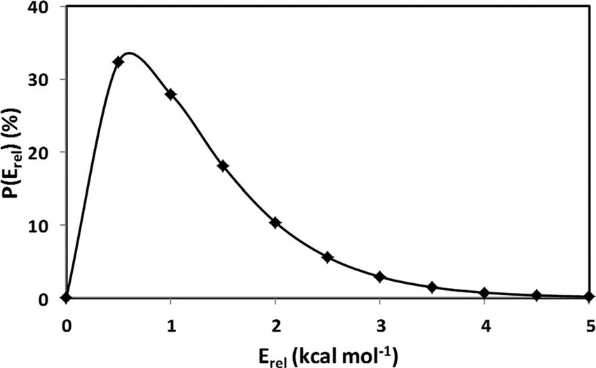
Figure 1. The abstract may contain a figure or two. Be careful, however, that the figures are large enough such that all labels and text on the figure are readable.

